**GUIDELINES FOR USE OF A RIGHT FROZEN CABINET**

*Freezer is a very popular product line for customers who are business households or restaurants and hotels. Eucalyptus helps you preserve the most food is fresh food, vegetables longer than ghosts still keep good quality.*

**Shipping and installation**

When transporting the freezer on the car, be careful not to leave the cabinet tilted over 45 ° to avoid damage. After transportation, keep the cabinet stable from 30 minutes to 1 hour before using the power plug.[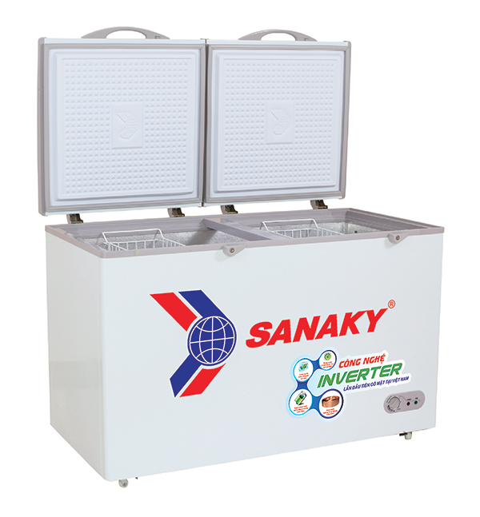](https://sanaky.com.vn/wp-content/uploads/2018/01/Tu-Dong-Sanaky-01.jpg)

Place the cabinet in a dry, dust-free and well-ventilated location to ensure ventilation behind the cabinet. Set the cabinet at least 10cm from the wall, do not use cloth paper, cover the condenser. Do not place cabinets in the sun.

Put the cabinet away from water, heat and volatile materials to prevent corrosion.

**Power source works**

The power cord must be large, ensuring that the load is at least 6A.

Current 220V-50Hz, if the power supply is unstable, use voltage stabilizer.

After plugging in the power, set the temperature control button at number 4, then the red light and green light will turn on, if there is a snow film sticking inside the cabinet, it proves that it works well.

After power failure / unplug, must wait at least 5 minutes to turn it back on.

**Adjust the temperature**

When the food in the cabinet is not much, it is recommended to adjust the cold level to medium to save power. With normal freezer products, you can adjust 4, 5 instead of MAX, if using less, you can adjust down to level 2, 3.

When the control button is in the OFF position, the cabinet switches to sleep mode**.**

**Food preservation**

To allow cold air to flow well in the cabinet for keeping cold and freezing, put food apart.

Do not put water bottles or cans in the freezer when the temperature is below 0 ° C.

For food, when frozen, the amount of water in food will be lost, so we should use wrap or sealed container for food when put in the freezer. This way also helps you limit the smell of food left in the cabinet.[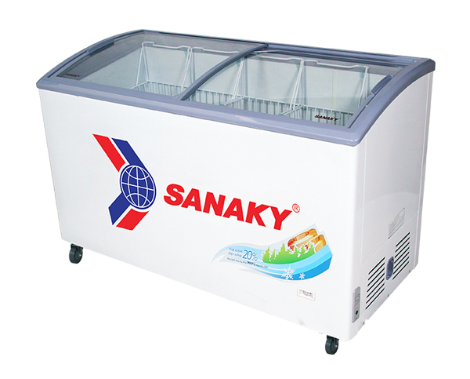](https://sanaky.com.vn/wp-content/uploads/2018/01/Tu-Dong-Sanaky-02.jpg)

For freezers used to make vitamins, should be equipped with plastic basket trays to help convective cold air in the cabinet, help fast food frozen.

Absolutely not reserve alkaline liquids and gases, acidity into cabinets.

**Hygiene and maintenance**

During use of the freezer, you should clean regularly. Before cleaning, disconnect and disconnect the power cord from the power outlet. Remove any remaining food from the cabinet, clean the inside of the cabinet with a few neutral detergents.

Do not use boiling water, acid, gasoline, chemicals to clean cabinets.

After cleaning, dry the inside of the cabinet.[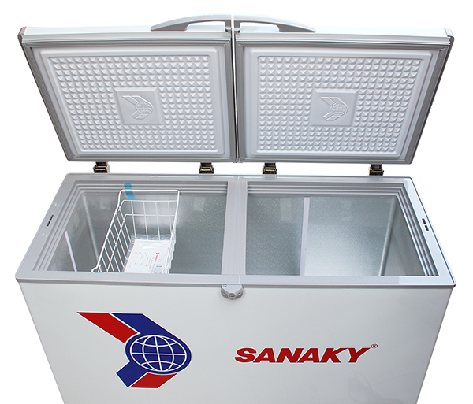](https://sanaky.com.vn/wp-content/uploads/2018/01/Tu-Dong-Sanaky-03.jpg)

*Use a mild soap to clean the cabinet, wipe it with clean water, and let it dry naturally.*

Use a soft cloth and some detergent to clean the outside of the cabinet. Avoid letting the power cord fall into place with water. Avoid splashing water into the whirlpool.

Except for common errors, other errors that occur must be checked by qualified technical personnel. The replacement and repair of electrical parts such as engine blocks, heat control are not allowed.

**Snow**

Turn the Thermostar control button from position (ON) or (OFF) to disconnect or unplug the power.

Put food, trays, and racks out of the freezer, open the cupboard door to melt the snow. Place the side of the cabinet with a pot of clean warm water, a clean cotton towel, a sponge (sponge) to wet, dry.

Use a soft clean cloth to clean the indoor unit of the freezer compartment, door panels and other plastic parts of the freezer. You can also use a thin soap to scrub the dirt and rinse it with clean water and dry.

When scrubbing to avoid standing water in the bottom of the cabinet, the door cushions, the freezer cover uses a clean cloth soaked in warm water, then wipe dry (do not use alkaline solution or any other substance, ... for scouring). Clean the hot plate with a soft cloth, do not wipe with a cloth that is too moist, causing water to flow into the box in the cyclone causing electric shock. Clean the underbody and cabinet (make sure it is dry and anti-rust and rodent). After cleaning inside and outside the freezer, dry in the groove and open the cabinet for 30-40 minutes for ventilation.